CL1002 - Programming Fundamentals

Project Meow
An Interactive Arduino Virtual Pet

KHADIJA BATOOL | SIBTAIN SAJJAD | SAMAAH HASHMI
25K-6515 | 25K-6547 | 25K-6510

SUBMISSION DATE: Tuesday, 28th April 2026
BSCE-2A



Project Meow: An Interactive Arduino Virtual Pet
OVERVIEW:
This project explores embedded systems through the creation of a virtual pet. It will feature a digital character whose "mood" changes based on real-time hardware inputs. It focuses on how software handles real-time inputs to simulate biological "needs".
The project successfully connected physical sensors, auditory feedback, and visual display within the memory constraints of an ATmega328P. The use of C++ Structures and Switch-Case logic effectively handled multiple pet variables at the same time, creating a reliable “nervous system” for continuous user interaction.

INTRODUCTION:
Standard procedural code is often insufficient for handling continuous, real-time user interactions. This project directly applies Programming Fundamentals concepts to a real-world hardware application to solve this problem.
OBJECTIVE: To build a fully playable interactive gadget that demonstrates a practical grasp of C++ Structures, Switch-Case logic, and basic Hardware Interfacing.

PROJECT DESCRIPTION:
"Project Meow" is an interactive virtual pet that "lives" on an Arduino microcontroller. The system includes a small OLED screen that displays the pet’s face. The pet features an internal timer tracking hunger and happiness. It includes Play and Feed push buttons, a Light Dependent Resistor (LDR) to trigger Sleep Mode, and a buzzer for sound effects. Users must interact with it via buttons to prevent its health from depleting (user must physically press the connected Feed or Play buttons to reset the pet's internal timers, which changes the face back to a happy expression).

Technical Overview: The software was developed and compiled using the Arduino IDE with standard C++ programming logic.
The hardware utilizes:
- Arduino Uno
- Breadboard, jumper wires, push buttons
- OLED screen, LDR, and a Piezo Buzzer.

METHODOLOGY:
A Modular Programming approach was implemented to keep the logic for the pet's "brain" (timers) separate from the graphics code, ensuring easier debugging. The behaviour system utilizes three primary conditions: Happy, Hungry, and Sad. The pet transitions to a Hungry or Sad state based on set time intervals, returning to a Happy state upon user interaction.
Additionally, an LDR light sensor detects low-light environments and triggers a Sleep Mode for the pet.

ROLES & RESPONSIBILITIES:
KHADIJA | SIBTAIN | SAMAAH
Acted as the Artist  designing the pixel frames and visual persona.  Helped with hardware assembly and verified all connections for the sensor and output devices | Acted as the Coder  implementing the beginner-friendly C++ logic, Structs, and Bitmap Arrays. | Acted as the Builder  handling the breadboard wiring, calibrating the voltage divider circuit, and physically assembling the components.

PROJECT IMPLEMENTATION:
Design & Structure:
The hardware components are grounded and stabilized on a modular Styrofoam base to prevent interference with the high-speed I2C communication bus. The software architecture defines C++ Structs for pet data management and uses a simple mood-based behaviour system.
Functionalities Developed:
The microcontroller constantly checks hardware inputs in real-time. Users must physically press the Feed & Play buttons to reset internal timers, returning the interface to a happy expression. A drop in voltage detected by the LDR triggers a state change into Sleep Mode.
The tone() function generates specific auditory feedback through the buzzer upon button presses.

CHALLENGES:
- The I2C communication between the Arduino and the OLED screen was initially unstable, causing the Hello Kitty face to glitch when the buttons were pressed.
- Resolved by troubleshooting the physical hardware, specifically securing the jumper wires more firmly into the breadboard.
- Initially, the LDR was too sensitive, so slight changes in room's lighting caused the OLED screen to rapidly switch between Sleep Mode and the normal face.
- Resolved by modifying the logic so that the Sleep Mode only activates under a much more obvious light change.
RESULTS:
Project Outcomes:
A working, playable prototype of the digital pet was successfully delivered alongside clean, C++ based source code. The hardware successfully acts as a responsive system.

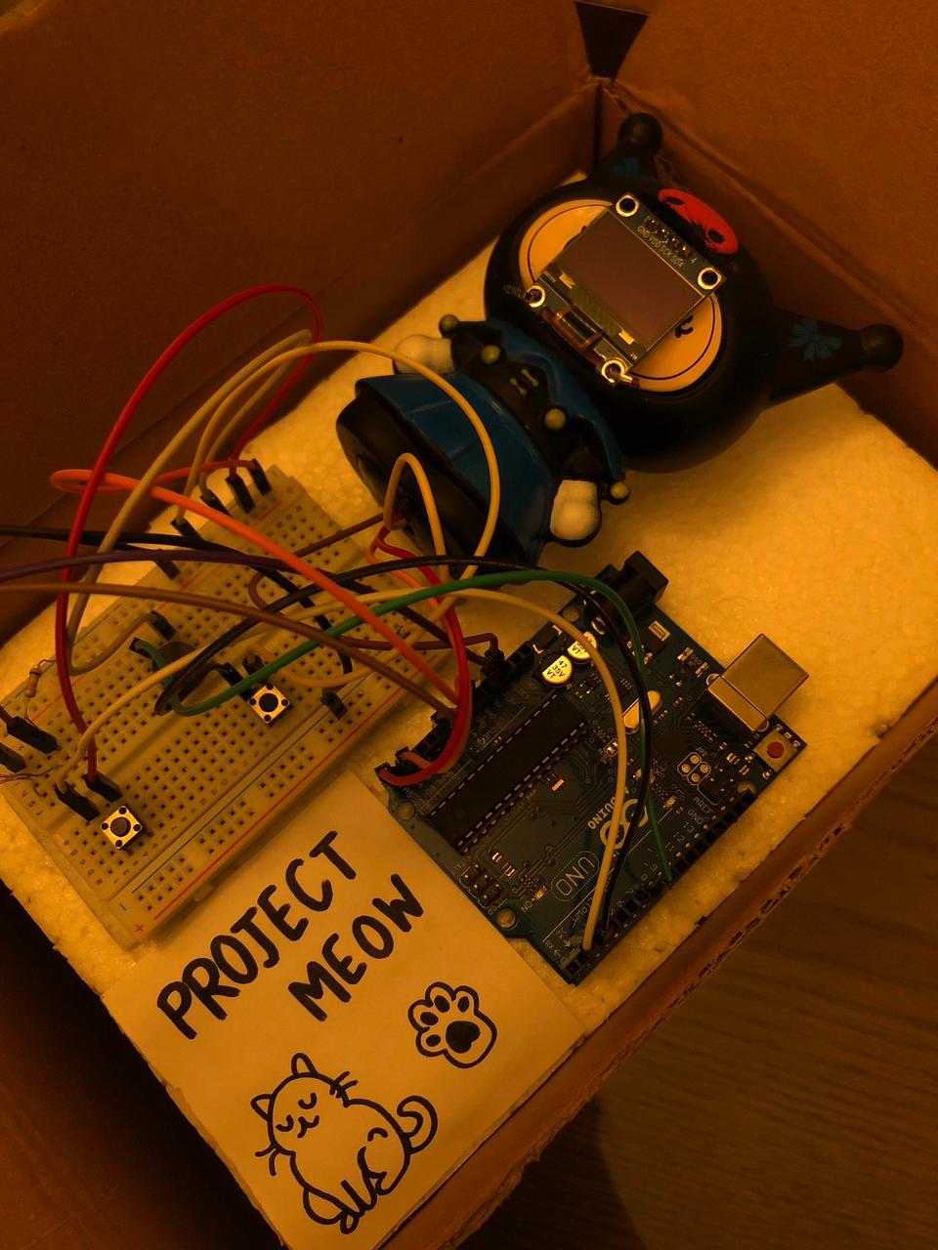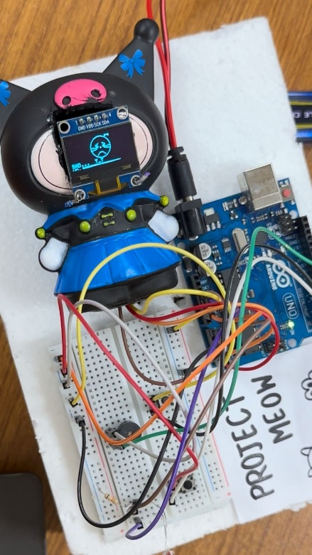
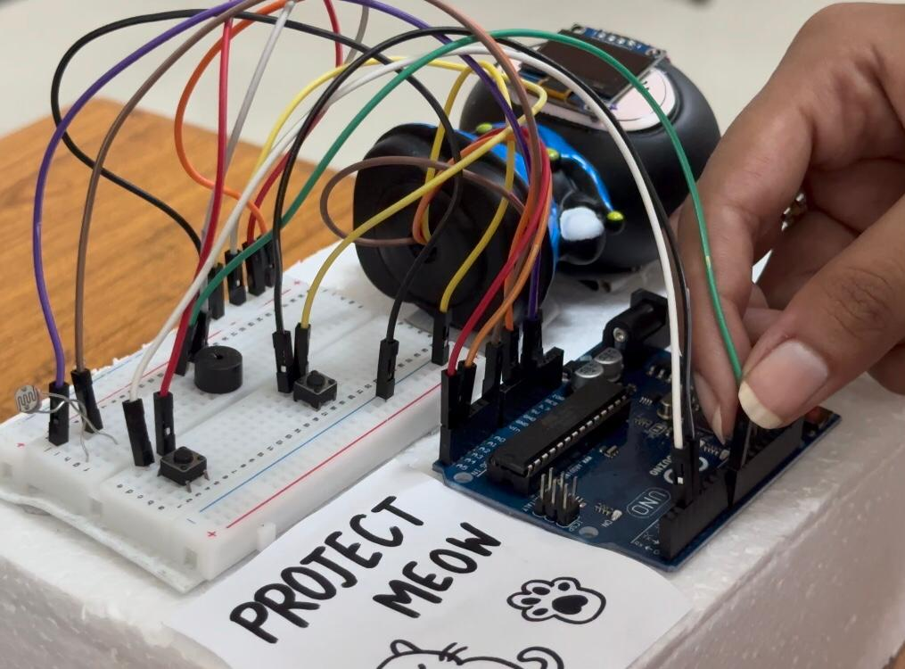

Testing and Validation:
The system was tested by manually covering the LDR, which successfully triggered the Sleep Mode state change. Button functionality was validated by observing the reset of the internal timers.

CONCLUSION:
Using structured C++ programming helped manage different variables and real-time inputs in a simple and organized way without overcomplicating the core logic. The project showed that hardware connections can be used to create real-time interaction.

By integrating real-time input signals with C++ based logic and audio feedback, the project bridges the gap between digital processing and physical interaction. It serves as a useful learning tool for understanding embedded systems and how responsive systems work.

